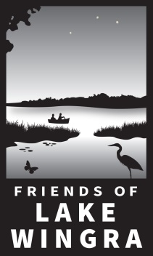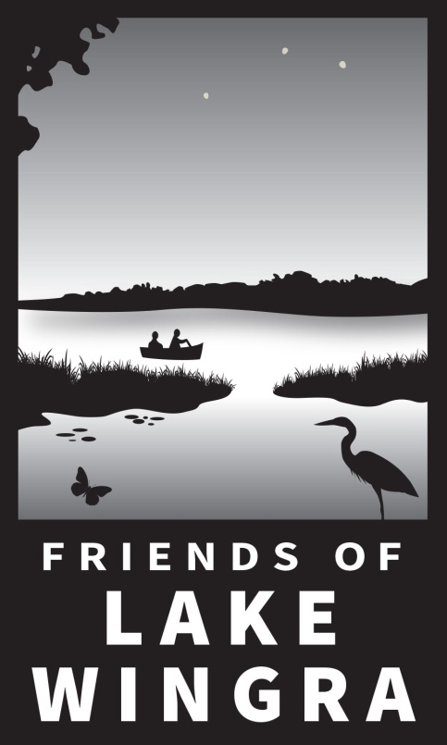

Form last revised: November 2017

**Via Online**

1. Go to [www.lakewingra.org/donate](http://www.lakewingra.org/donate)
2. Click the PayPal Donate button.
3. Fill out donor card online at https://www.lakewingra.org/donor-form.

**Via IRA or 401(k)**

Donations can be made directly from IRAs or 401(k) investments for those taking Required Minimum Withdrawals.

1. For first timers: Contact your investment administrator.
2. Past donors: Inform your investment administrator that Friends of Lake Wingra, Inc. has recently received its own 501(c)(3) charitable organization approval, independent from Edgewood College.

For my charitable donation, I have enclosed a check for $________ in the amount listed below.

Name: ________________________________________________ I filled out my donor card online.

Mailing Address: ___________________________________________

___________________________________________

Phone*: ( ) ______ - _________ *Used only if we need to contact you about your donation.

Email: ______________________________________________ I want my newsletter emailed only.

Let me know about volunteer opportunities!

I want my donation to remain anonymous please.

My employer has a matching gift program, and I’ve enclosed the form.

**Friends of Lake Wingra Donor Card**

If donating by mail, please fill out and include with donation.

**Via Mail**

1. Make check payable to:

Friends of Lake Wingra, Inc.

1. Fill out donor card below or fill out online at https://www.lakewingra.org/donor-form
2. Send check and donor card to:

PO Box 45071

Madison, WI 53744-5071

If applicable, include employers matching gift form.

**Our address has changed!** We are now an independent 501(c)(3) nonprofit organization and are no longer housed under Edgewood College. If you are a new or repeat donor, please check our new instructions to make sure your donation gets to us. Thank you for making a donation to Friends of Lake Wingra!

**I’M A FRIEND OF LAKE WINGRA!**

**Donor Instructions**

**Thank you for your donation!**

Your information is for our private and exclusive use. We will not share your contact information with anyone without your express permission.

**Reach us at:** info@lakewingra.org

Friends of Lake Wingra is a registered 501(c) (3) nonprofit organization.